|  |  |  |  |
| --- | --- | --- | --- |
| Name:  Class: | ____________________________________  ________________ | | Date:_________ |
|  | **Year 12 Essentials**  **Test 1, 2021**  **Topic – Measurement / Right Angle Triangles** | | / 45  10% |
| **Total Time:** | *50 min TOTAL* |  | |
| **Weighting:** | *5 %* |
| **Equipment:** | *1 A4 page of notes (one side) and Calculator* | | |

|  |
| --- |
| **Question 1*****6 marks*** |

State what unit of capacity (millilitres, litres, megalitres or gigalitres) you would use when measuring the capacity of

i)

1. A cup of coffee
2. The swimming pool from your investigation
3. Dosage of liquid medicine for children
4. Serpentine Dam (one of our metropolitan dams)

ii) a) Convert 31 metres to millimetres b) Convert 40,000cm2  to m2

|  |
| --- |
| **Question 2*****3******marks*** |

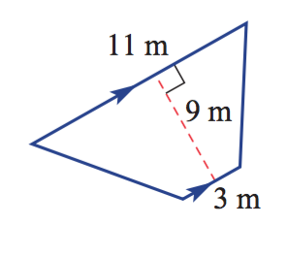

1100cm

1. Name the 2-D shape.

10m

1. Calculate the perimeter of the shape in metres (m)

13m

300cm

1. Calculate the area of the shape.

|  |
| --- |
| **Question 3** ***3 marks*** |

A can of coke is 325 millilitres. What is the total volume of 7 lots of 24 can cartons? Give your answer in litres.

|  |
| --- |
| **Question 4 *4 marks*** |

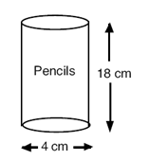

A cylindrical pencil holder is shown. The height is 18 cm and the diameter 4 cm.

(a) What is the capacity of the pencil holder in cm3 ?

(b) The outer curved surface area is covered with coloured paper. What is the area of the paper?

|  |
| --- |
| **Question 5 6 *marks*** |

Kirstie wishes to paint the tool shed (pictured) with two coats of zinc alum-paint. Each litre of zinc-alum covers 5m2 and costs $8.50. It must be purchased in whole litres.

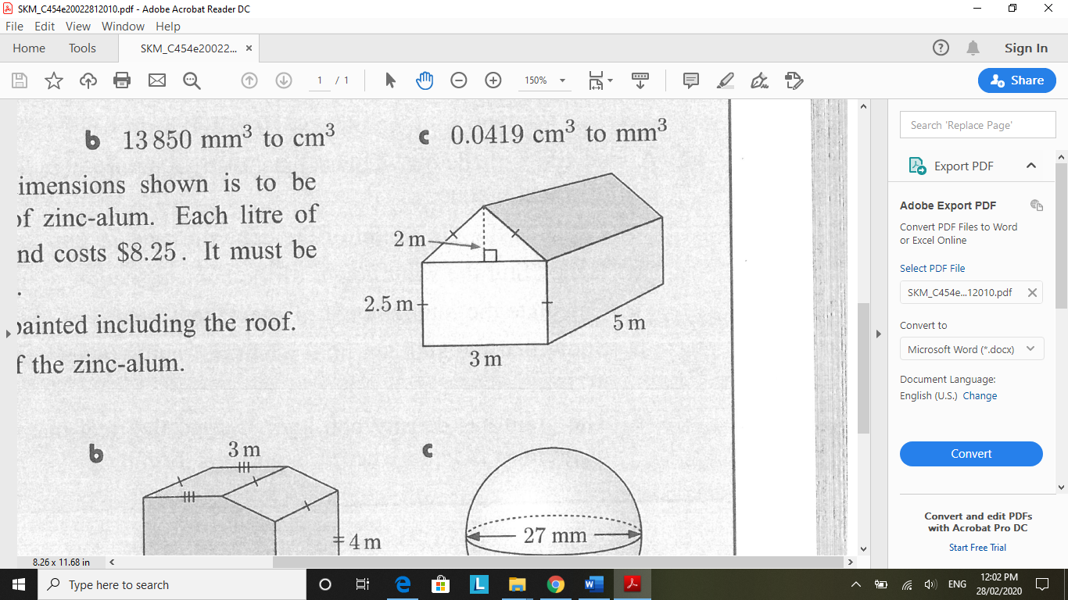

1. Find the area to be painted including the roof.
2. Find the total cost of the zinc-alum paint.

|  |
| --- |
| **Question 6  *2 marks*** |

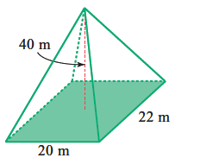

1. Name the 3-D shape
2. Calculate the volume of the 3-D shape.

|  |  |
| --- | --- |
| **Question 7 *2,1 marks*** | |
| 1. Which of the following is a right angled triangle, and explain your reasoning. |

|  |
| --- |
| **Question 8 *3 marks*** |

1. Use the triangle $∆$ DXP to answer the following questions
2. 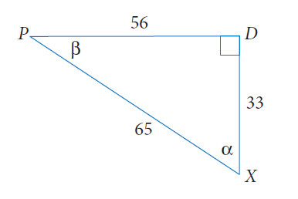How long is the hypotenuse?
3. What is the length of the side opposite to $α$?
4. How long is the side adjacent to $β$

|  |
| --- |
| **Question 9 *6 marks*** |

1. Determine missing side of a triangle marked with pronumerals. Express your answers to 1 decimal place.

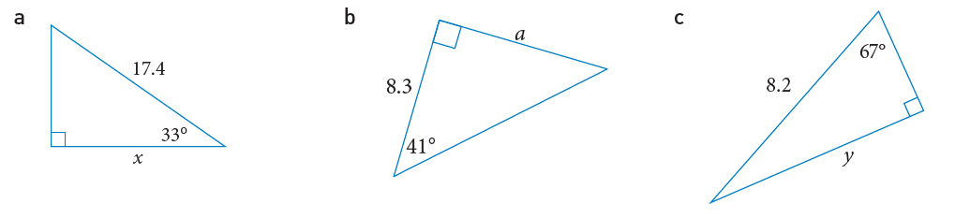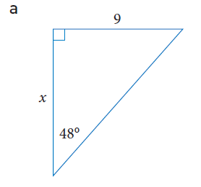

|  |
| --- |
| **Question 10 3 *marks*** |

The council is going to build a children’s slide in the park. The top of the slide will be 2.6 m high and the slide will make an angle of 31 $°$ with the ground. Calculate the length of the slide, correct to 2 decimal places.

|  |
| --- |
| **Question 12 6 *marks*** |

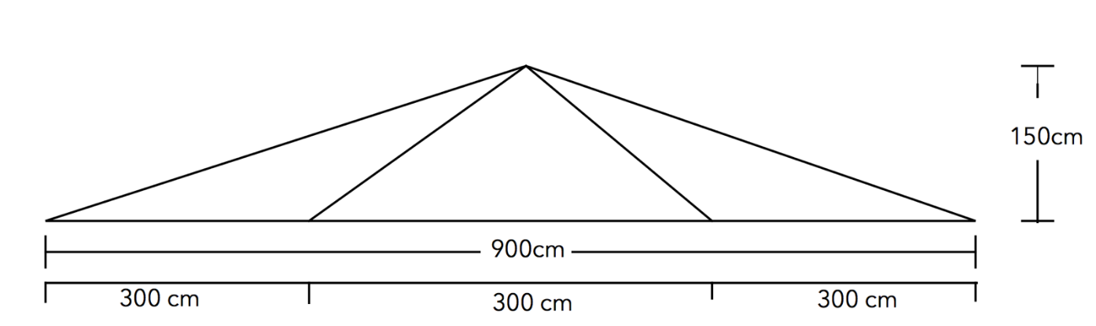Sam builds a roof support. It is 900cm wide, 150cm tall and is supported by 4 diagonal beams. The two outer beams are the same length, and the two inner beams are the same length. How much total wood would Sam need to build their structure?

**End of Test**